community development Qualification Worksheet

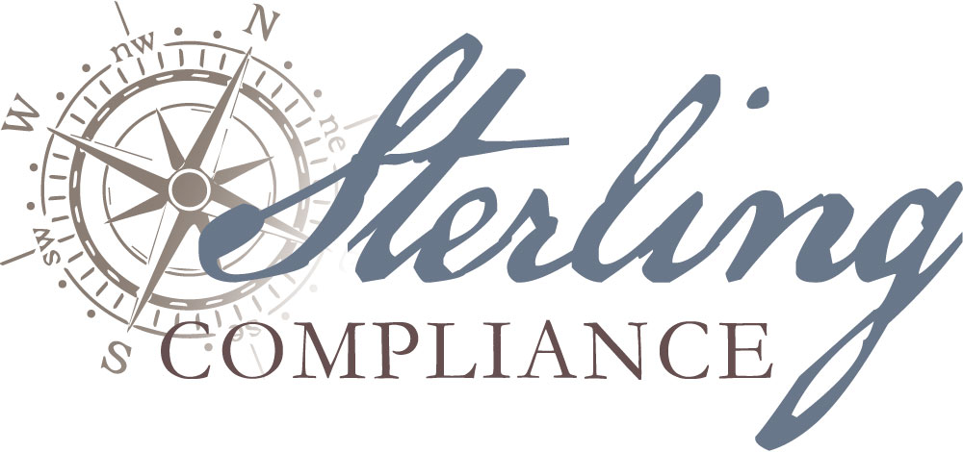

|  |  |  |  |  |
| --- | --- | --- | --- | --- |
| **Qualifying Classification** | **LOAN** | **INVESTMENT** | **SERVICE** | **DONATION** |
| **Qualifying Item: Short Name[1]** |  | | | |
| **Dollar Amount of Loan, Investment, or Donation** |  | | | |
| **Date of Loan, Investment, Service or Donation** |  | | | |
| **Description of Loan, Investment, Service[2] or Donation** |  | | | |
| **Indicate Assessment Area Benefiting from Loan, Investment, Service or Donation** |  | | | |
| **Does the Loan, Investment, Service or Donation Benefit a Distressed or Underserved Area?** | YES Designated Census Tracts: | | NO | |
| **For CD Loans: Has this loan been reported for HMDA purposes?** | YES[3] | | NO | |
| **Eligibility Criteria Met** *Check ALL that apply.* | Provides **affordable housing** for low- or moderate-income **(LMI)** individuals  Provides **community services** for **LMI** individuals  Supports activities that promote **economic development** by providing financing for small businesses or small farms  **Revitalize or stabilize LMI** geographies  Supports activities that **enable or facilitate projects or activities that meet “eligible uses[4]” criteria** described within Section 2301(c) of the Housing and Economic Recovery Act of 2008 and are conducted in designated target areas identified in plans approved by HUD in accordance with the Neighborhood Stabilization Program | | | |
| **Description of HOW Loan, Investment, Service or Donation Meets Eligibility Criteria[5]** |  | | | |

1. Enter the name of the borrower(s) for CD Loans, the name of the investment purchased for CD Investments, or the name of the entity to which a service was provided or donation made, as applicable
2. Notate the name(s) of the individual(s) performing identified service
3. If the loan is secured by a multi-family property that would otherwise qualify as a community development loan, continue completing the worksheet. Multi-family properties that have been reported for HMDA purposes may still qualify for community development credit.
4. Financing mechanisms for foreclosed properties; purchase and rehab of abandoned or foreclosed housing and residential properties; demolition of blighted structures; and, redevelopment of demolished or vacant properties.
5. (ref. <http://www.occ.treas.gov/topics/community-affairs/publications/fact-sheets/fact-sheet-cra-loans.pdf> )